**Vision Document for “CRM”**

**Team members:**

*Caio Schwarcz Hoffmann – 610093*  
*Widjesh Bhaggan - 610128*

**1. Introduction**

A travel agency company has stores in 4 difference countries. When a customer calls to the travel agency and some of the coworkers picks up the phone, he/she can open a ticket in the system. This ticket can be passed to a specific coworker or can just be placed in the list. This ticket will contain the customer his phone number, where he called from and what he/she wants information about. The next available coworkers who is available to help this customer will complete this ticket and set the status on completed. The system will take care of how many employees opened a ticket and how many employees has completed the ticket. There will be a list of all the employers with their total of ticket opened and ticket completed. On basis of this the company can reward such an employee as employee of the month or year.

Procedure:

Customer calls to the travel agency and the coworkers who picks up the phone will place this customer in the list with their information. The employee will pass this particular ticket to another employee if he knows exactly which employee can help him. If the employee who opens the ticket doesn’t want to pass the ticket to another employee then it gets placed in a regular list of all tickets which are not completed yet. So, the next available coworker will call the customer and provide him the information where the employer will have a description box, where he will provide the communication between him and the customer. The administrator can keep track of what the communication was between them and help improve if something went wrong.

**2. Positioning**

**2.1 Problem Statement**

*Create a system to manage tickets between staff in the company*

|  |  |
| --- | --- |
| The problem of | *Manage tickets between* |
| Affects | *Staff, costumer* |
| the impact of which is | *A costumer might need help to get a service, so a ticket is created and it might need to be passed to a specific coworker to be fulfilled* |
| a successful solution would be | *One tool that regulates the tickets in the company, makes sure that all tickets are placed in a line to be resolved and that help increase visibility to staff that completes more tickets* |

**2.2 Product Position Statement**

|  |  |
| --- | --- |
| For | *Travelling company* |
| Who | *Staff* |
| The (product name) | *CRM* |
| That | *Manages tickets throughout the company and it helps to show staff productivity* |
| Unlike | *?* |
| Our product |  |

*[A product position statement communicates the intent of the application and the importance of the project*

*to all concerned personnel.]*

**3. Stakeholder Descriptions**

**3.1 Stakeholder Summary**

|  |  |  |
| --- | --- | --- |
| **Name** | **Description** | **Responsibilities** |
| **Admins** | Admins add, edit or delete staff and company stores | Admins are responsible for setting up initial data and managing system. |
| **Employee** | Employees manage tickets, send tickets for particular coworkers and create new customers. | Employees will receive calls from customers and will create tickets based on the needs of the customer and might create a new customer in the system if needed |
| **Customer** | Customer will need assistance and request assistance by calling and creating tickets and need to receive feed back after the ticket is finished. | The customer needs to contact the employee and need to be informed that the ticked was created and finished. |

**3.2 User Environment**

*[Detail the working environment of the target user. Here are some suggestions:*

*Number of people involved in completing the task? Is this changing?*

*How long is a task cycle? Amount of time spent in each activity? Is this changing?*

*Any unique environmental constraints: mobile, outdoors, in-flight, and so on?*

*Which system platforms are in use today? Future platforms?*

*What other applications are in use? Does your application need to integrate with them?*

*This is where extracts from the Business Model could be included to outline the task and roles involved,*

*and so on.]*

**4. Product Overview**

**4.1 Product Perspective**

*[This subsection of the* ***Vision*** *document puts the product in perspective to other related products and the*

*user’s environment. If the product is independent and totally self-contained, state it here. If the product is a*

*component of a larger system, then this subsection needs to relate how these systems interact and needs to*

*identify the relevant interfaces between the systems. One easy way to display the major components of the*

*larger system, interconnections, and external interfaces is with a block diagram.]*

**4.2 Assumptions and Dependencies**

*[List each factor that affects the features stated in the* ***Vision*** *document. List assumptions that, if changed,*

*will alter the* ***Vision*** *document. For example, an assumption may state that a specific operating system will*

*be available for the hardware designated for the software product. If the operating system is not available,*

*the* ***Vision*** *document will need to change.]*

**4.3 Needs and Features**

*[Avoid design. Keep feature descriptions at a general level. Focus on capabilities needed and why (not*

*how) they should be implemented.]*

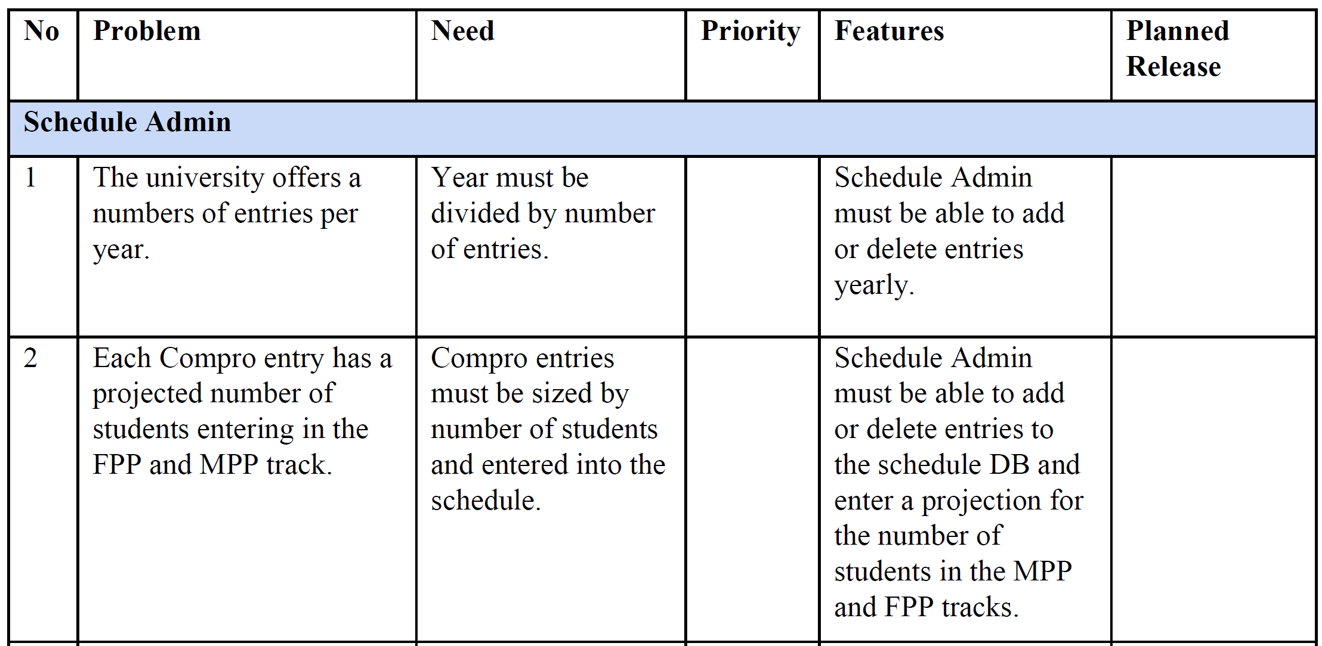

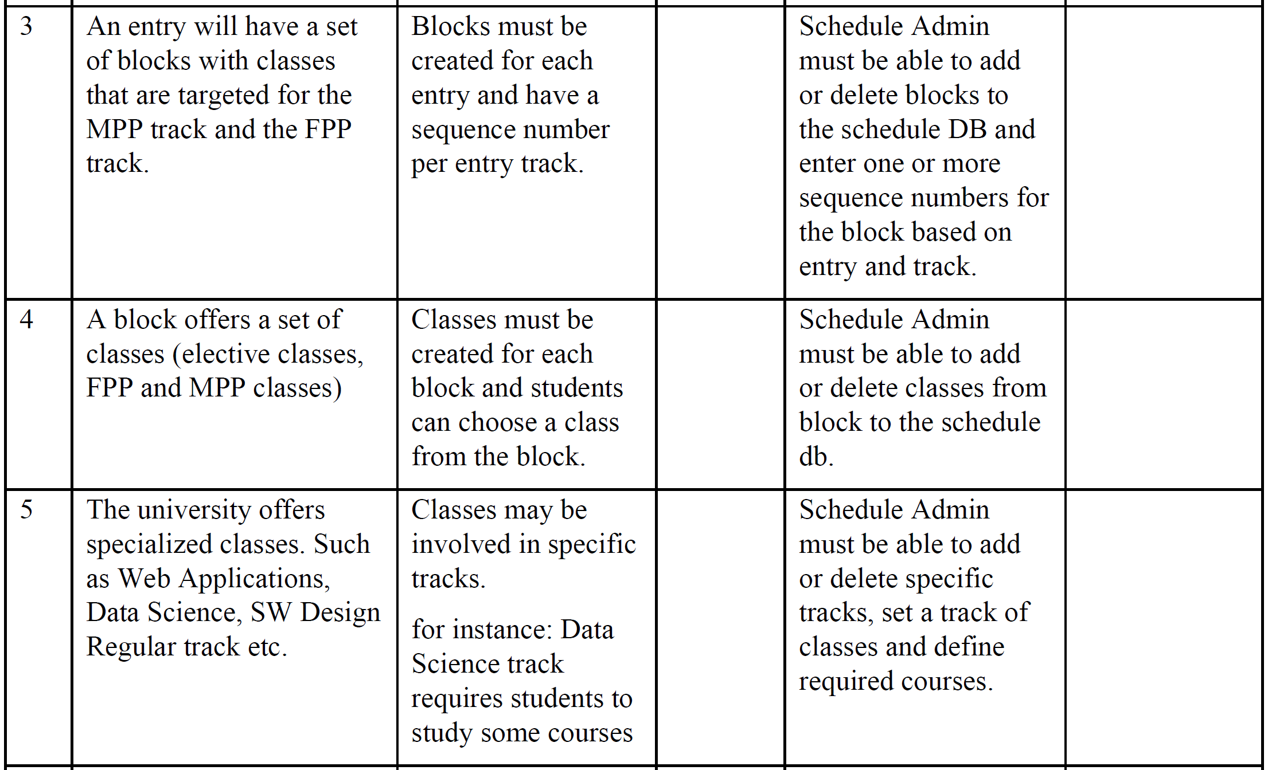

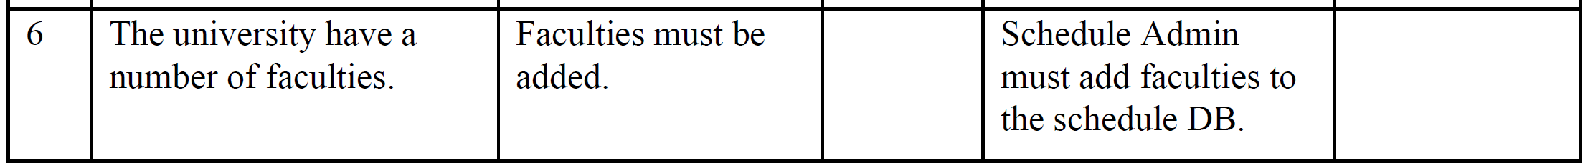

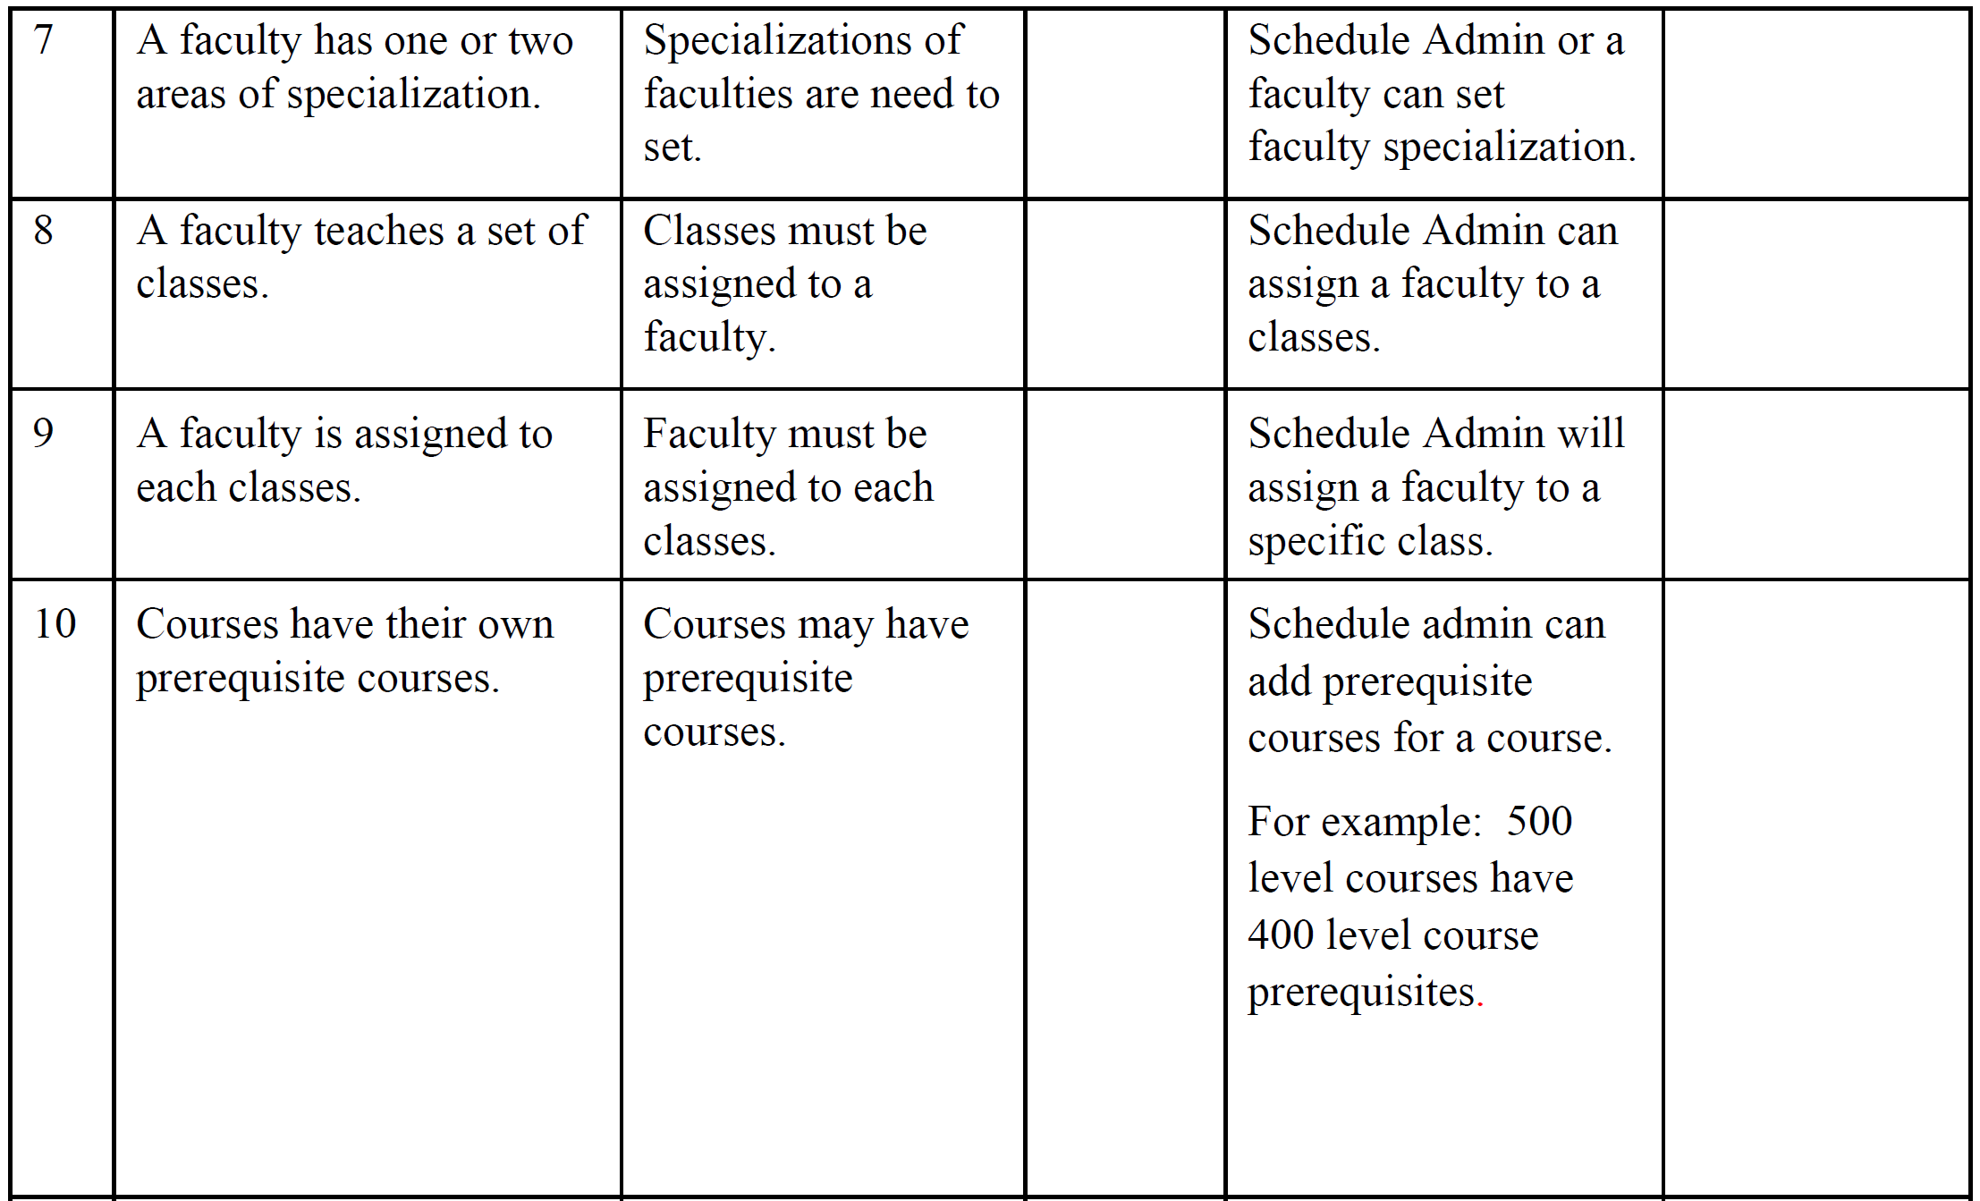

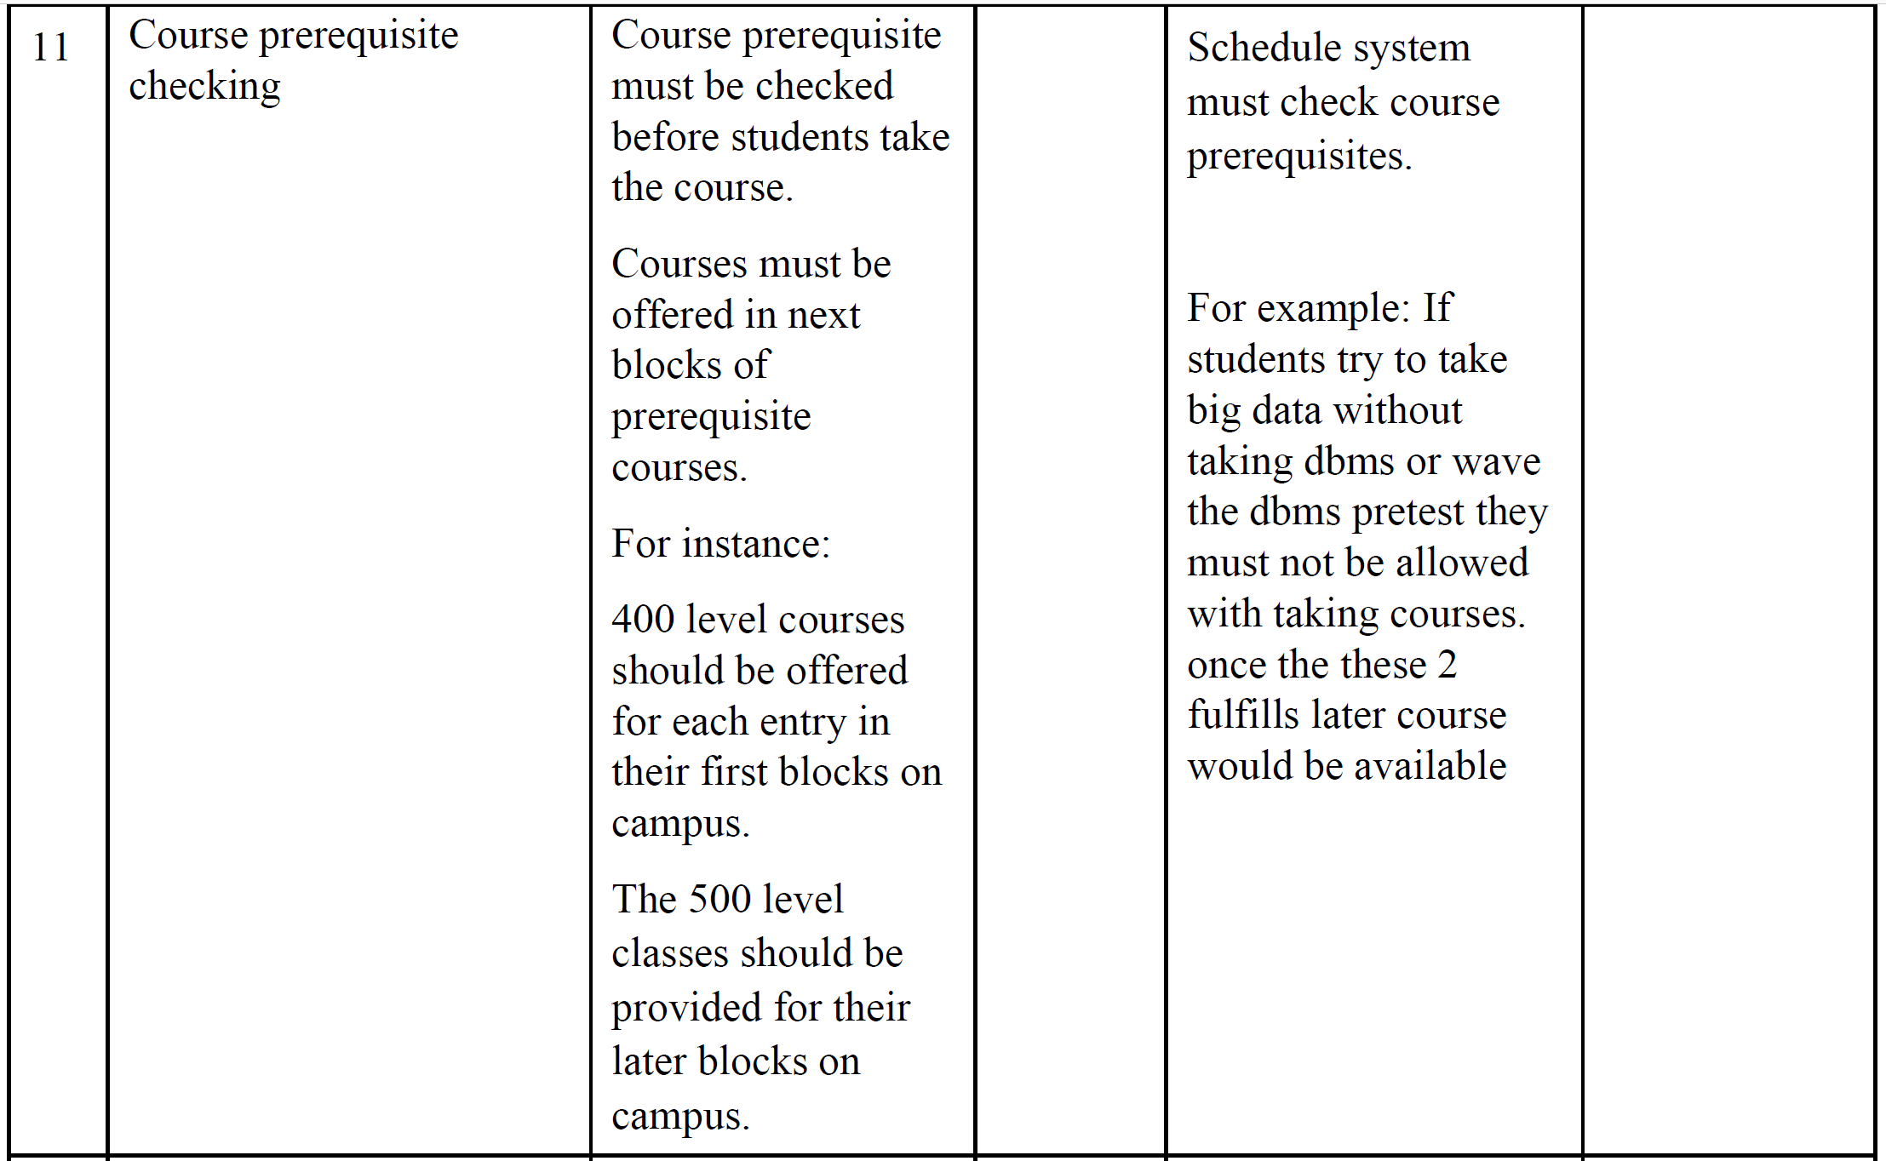

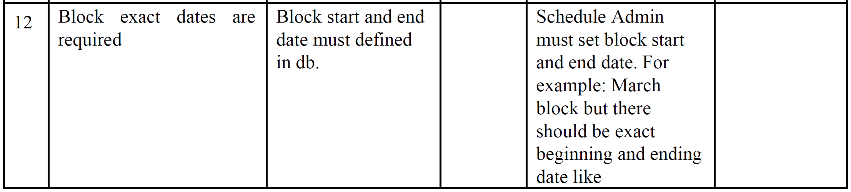

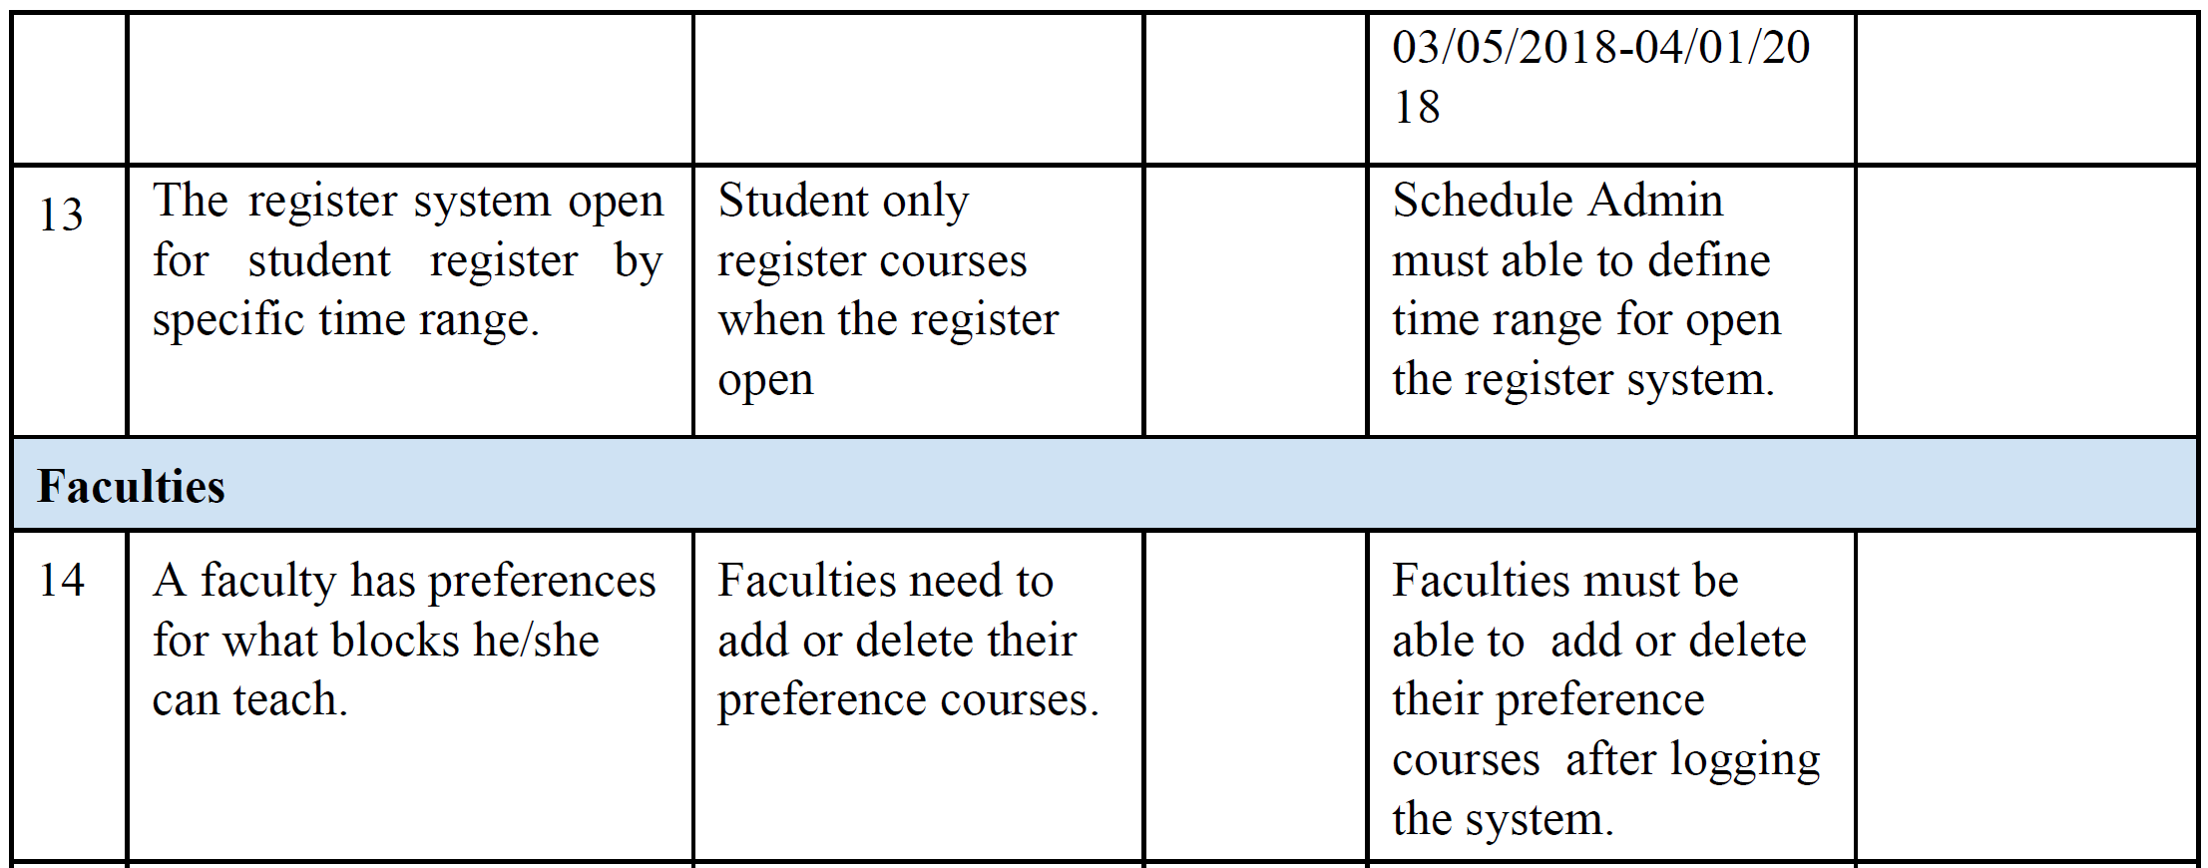

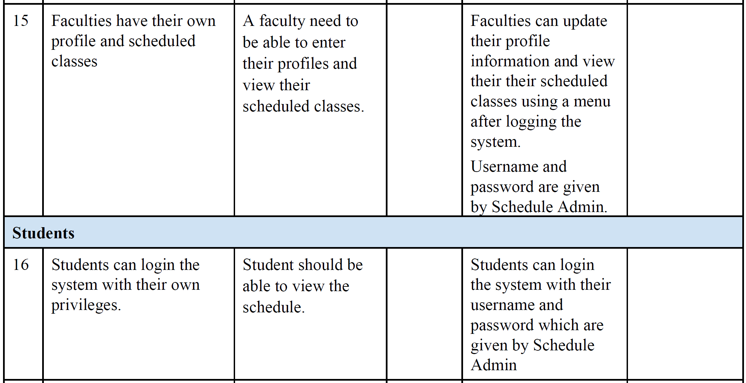

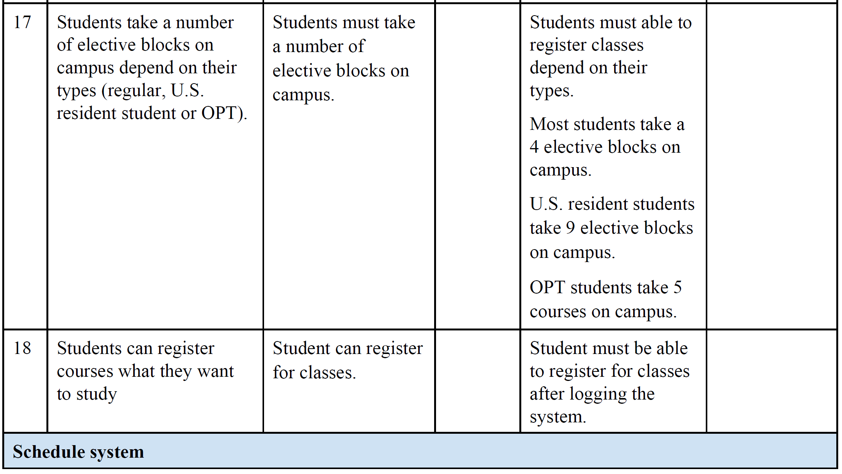

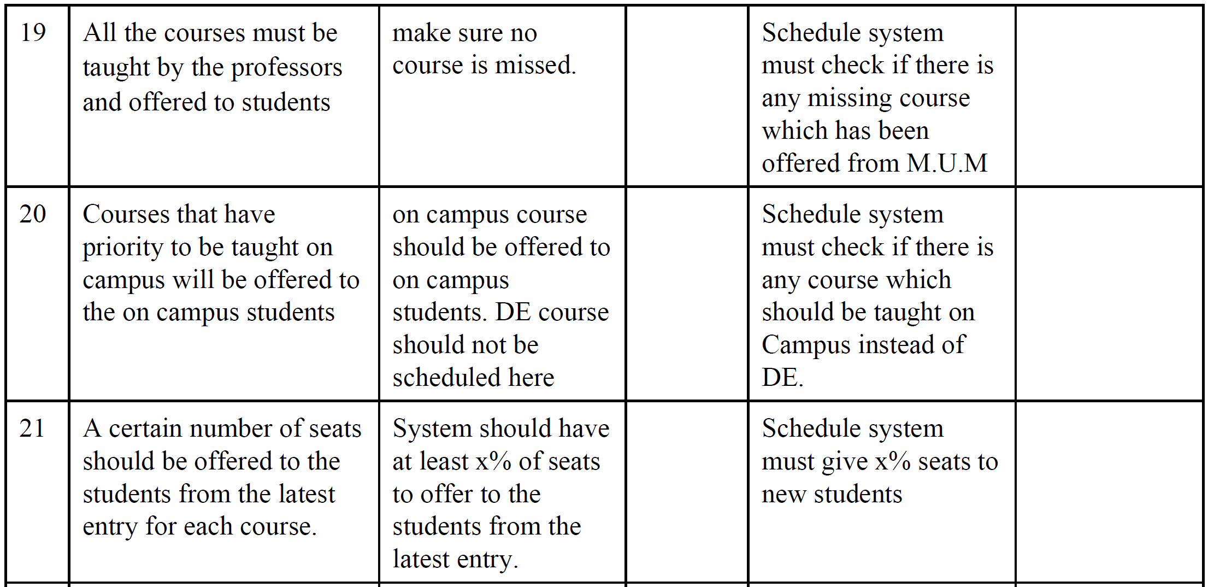

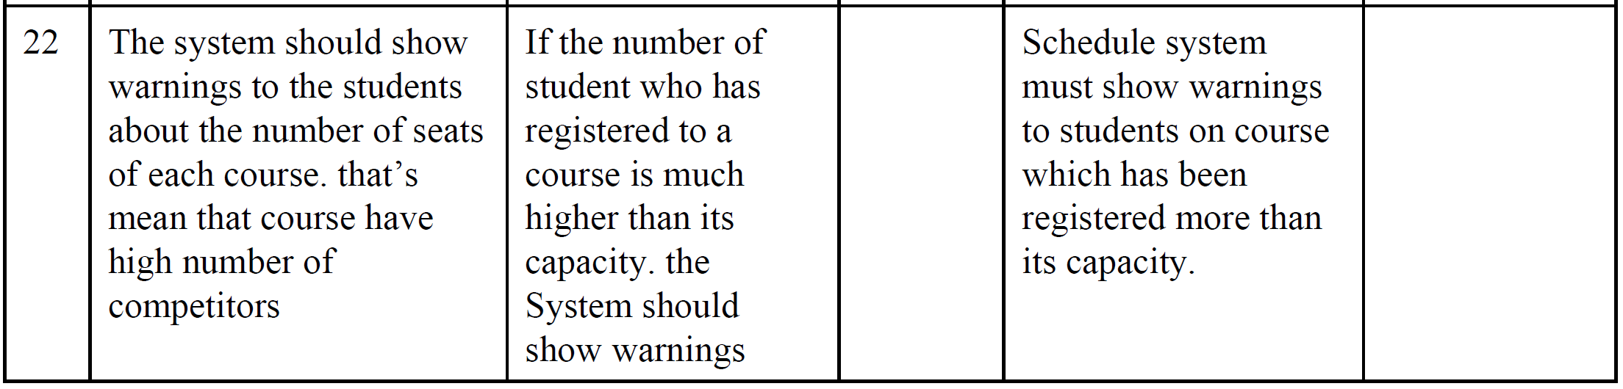

**4.4 Alternatives and Competition**

*[Identify alternatives the stakeholder perceives as available. These can include buying a competitor’s*

*product, building a homegrown solution, or simply maintaining the status quo. List any known competitive*

*choices that exist or may become available. Include the major strengths and weaknesses of each competitor*

*as perceived by the stakeholder or end user.]*

**5. Other Product Requirements**

*[At a high level, list applicable standards, hardware, or platform requirements; performance requirements;*

*and environmental requirements.*

*Define the quality ranges for performance, robustness, fault tolerance, usability, and similar*

*characteristics that are not captured in the Feature Set.*

*Note any design constraints, external constraints, or other dependencies.*

*Define any specific documentation requirements, including user manuals, online help, installation,*

*labeling, and packaging requirements.*

*Define the priority of these other product requirements. Include, if useful, attributes such as stability,*

*benefit, effort, and risk.]*